
Jayaprakash Narayan College of Engineering
Autonomous Institute | Affiliated to JNTUH Hyderabad

Project Report on
HEART DISEASE PREDICTION USING K-NEAREST NEIGHBORS (KNN) ALGORITHM

SUBMITTED BY:
NAZMEEN BEGUM (23266-CS-085)
P. JAYANTHI (23266-CS-094)
D. AKSHITH (23266-CS-089)
P. YASHWANTH (23266-CS-087)

Under the guidance of
Ms. ANEES SULTANA

CONTENTS:
Objective 1
Procedure 1
Introduction to Machine Learning 4
K-Nearest Neighbors (KNN) 4
Libraries 5
Code 6
Data Visualization 7
Conclusion 13

Heart Disease Prediction using K-Nearest Neighbors (KNN) Algorithm

Objective:

The main objective of this project is to predict whether a patient is likely to have heart disease using the K-Nearest Neighbors (KNN) classification algorithm. The prediction is based on clinical features such as age, sex, blood pressure, cholesterol levels, maximum heart rate, and other medical attributes. This project demonstrates how supervised machine learning can assist in healthcare by identifying risk patterns in patient data.

Procedure:
Step 1: Data Loading and Preparation
- Load the CSV file containing the dataset using pandas
- Rename the columns from medical abbreviations to full descriptive names for better understanding
- The dataset contains various medical parameters related to heart health

Step 2: Feature and Target Variable Separation
- Create the feature set (x) containing all independent variables:
- Age of the patient
- Gender (sex)
- Type of chest pain experienced
- Resting blood pressure
- Serum cholesterol level
- Fasting blood sugar status
- Resting electrocardiographic results
- Maximum heart rate achieved
- Exercise-induced angina
- ST depression induced by exercise
- Slope of peak exercise ST segment
- Number of major blood vessels coloured by fluoroscopy
- Thalassemia status
- Create the target variable (y) which indicates the presence or absence of heart disease

Step 3: Data Splitting
- Split the entire dataset into training and testing subsets
- Use 20% of the data for training the model
- Use 80% of the data for testing the model
- Set random_state parameter to 42 to ensure reproducible results

Step 5: Feature Scaling
- Initialize the StandardScaler for normalizing the feature values
- Fit the scaler on the training data to learn the mean and standard deviation
- Transform the training data using the learned parameters
- Transform the testing data using the same parameters (without fitting again)

Step 4: Model Creation and Training
- Initialize the K-Nearest Neighbors classifier
- Set the number of neighbors (k-value) to 5
- Train the model using the training data
- The model learns patterns from the training features and their corresponding target values

Step 6: Prediction
- Use the trained KNN model to make predictions on the test data
- The model compares each test instance with the training instances
- Based on the 5 nearest neighbors, it predicts whether the patient has heart disease

Step 7: Model Evaluation - Confusion Matrix
- Create a confusion matrix to evaluate the model's performance
- The matrix compares the actual target values with the predicted values
- It shows four categories: true positives, true negatives, false positives, and false negatives

Step 8: Visualization
- Create a visual representation of the confusion matrix using a heatmap
- Add a title showing the model's accuracy percentage
- Label the x-axis as "Predicted Label"
- Label the y-axis as "Actual Label"
- Add a colour bar to indicate the scale of values
- Display the plot to visualize the model's performance

Step 9: Results Interpretation
- Analyze the confusion matrix to understand the model's performance
- Calculate the accuracy score from the confusion matrix values
- The accuracy percentage indicates how often the model makes correct predictions
- The visualization helps in quickly identifying patterns in correct and incorrect predictions
MACHINE LEARNING

Machine Learning (ML) is a branch of Artificial Intelligence (AI) that focuses on teaching computers to learn from data and make decisions or predictions without being explicitly programmed for every single task. The machine learning is a autonomous acquisition of knowledge through the use of computer programs.

How ML Works (Basic Steps):

Collect Data – Give the system examples (e.g., past sales, images, texts).

Train a Model – Let the algorithm learn patterns from the data.

Test the Model – Check if it gives correct predictions on new, unseen data.

Make Predictions – Use it in real-life to make decisions or predictions.

K-NEAREST NEIGHBORS (KNN) ALGORITHM

The K-Nearest Neighbors (KNN) algorithm is one of the simplest yet most effective supervised machine learning algorithms. It can be used for both classification (predicting a label) and regression (predicting a continuous value).

How KNN Works: The Core Intuition

KNN is a non-parametric, lazy learning algorithm.

Non-parametric: It doesn't make assumptions about the underlying data distribution.

Lazy learning: It doesn't "learn" a model during training. Instead, it stores the entire dataset and performs calculations only when a prediction is requested.

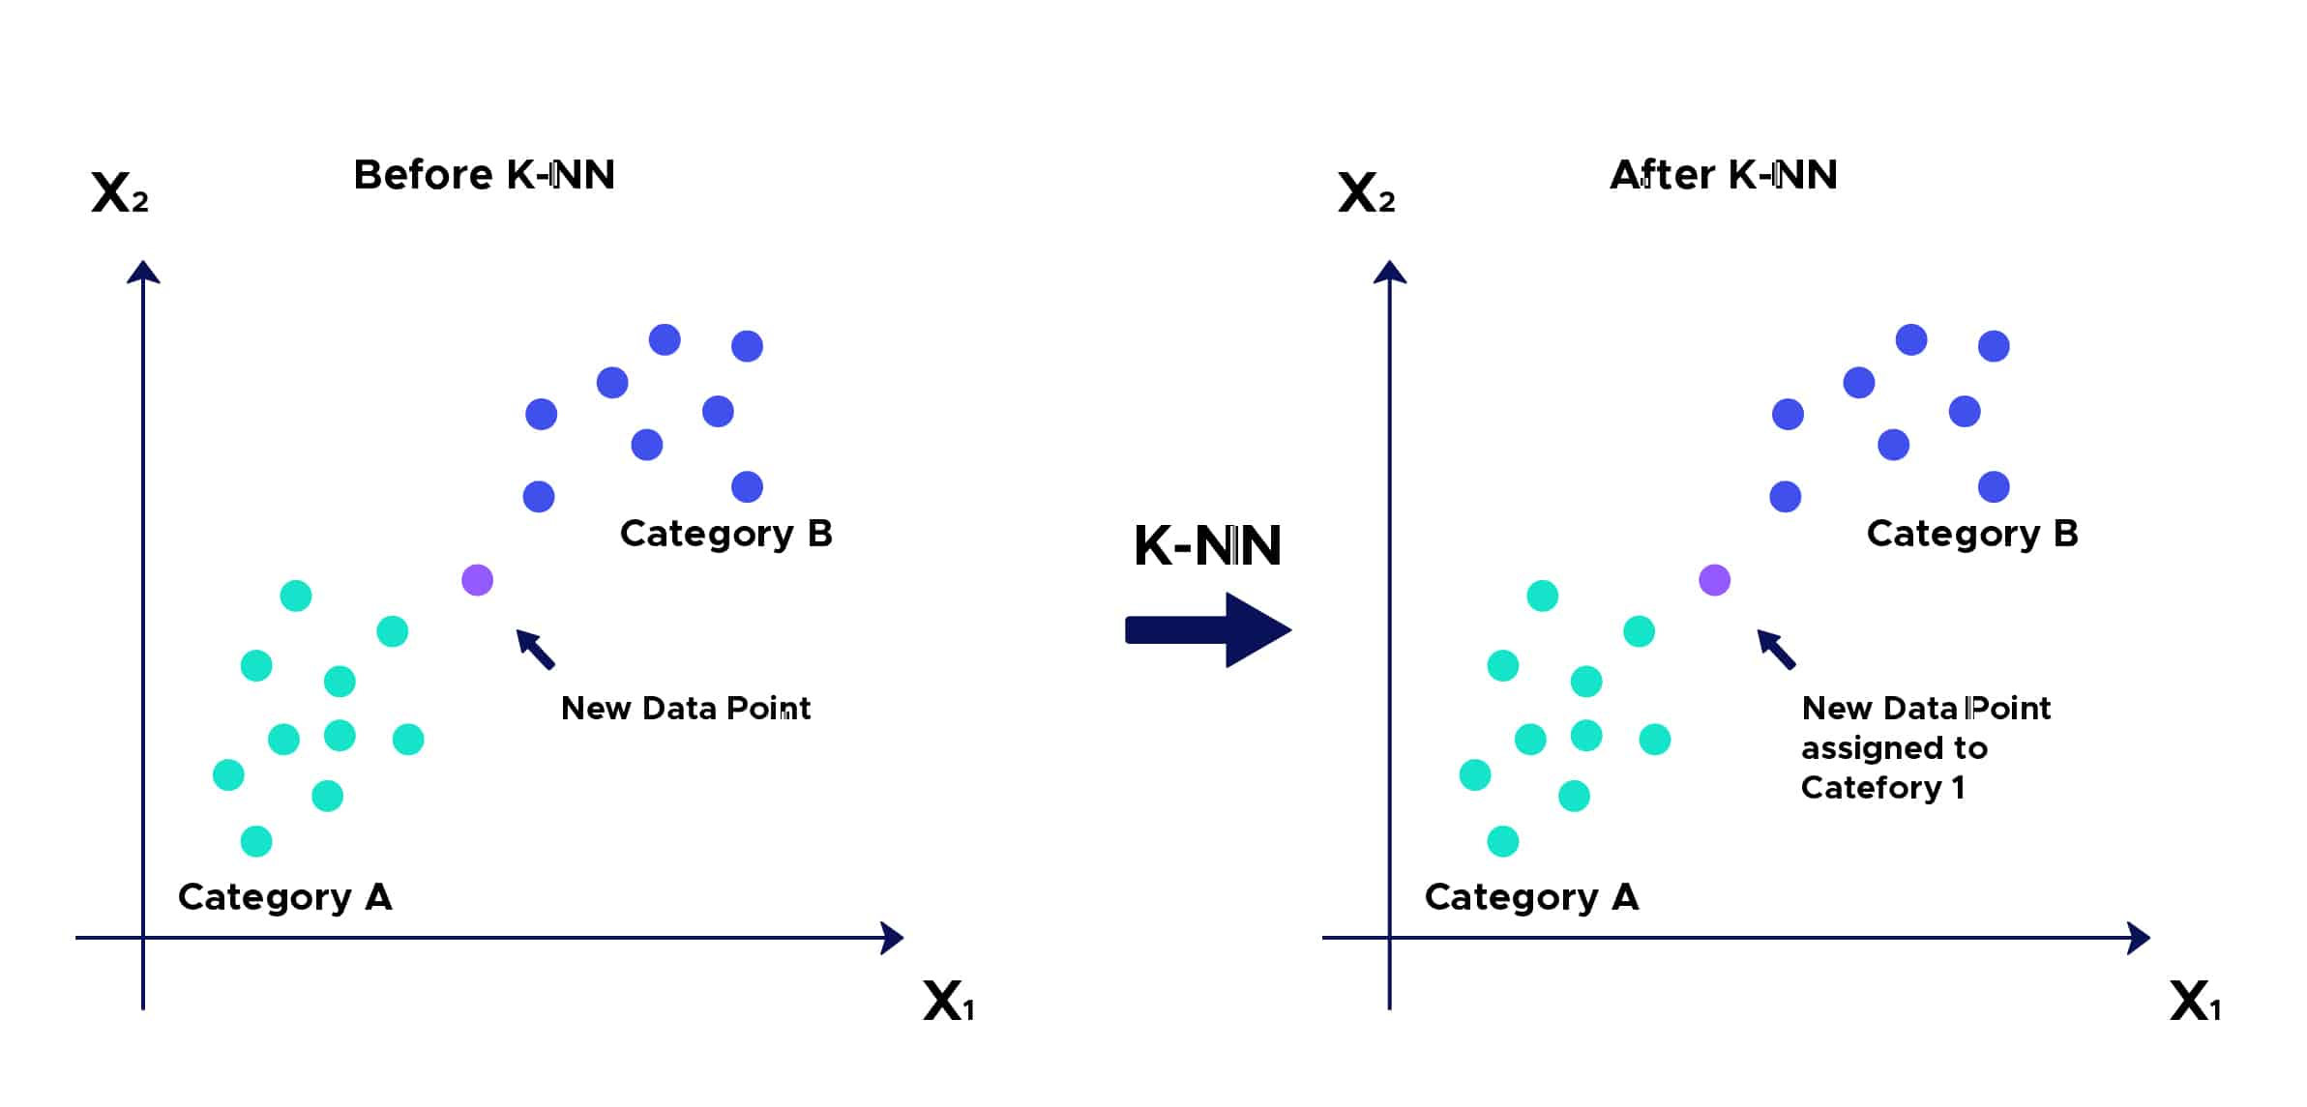

LIBRARIES USED

1. Pandas: A powerful open-source data analysis and manipulation library for Python.

Provides DataFrame object for handling structured, tabular data efficiently

Offers tools for reading/writing data between in-memory data structures and different file formats

Enables data cleaning, transformation, merging, reshaping, and aggregation operations

2. matplotlib.pyplot: A comprehensive plotting library for creating static, animated, and interactive visualizations.

Provides MATLAB-like interface for creating various types of plots and charts

Supports customization of plots with titles, labels, legends, and color schemes

Allows saving visualizations in multiple formats for reports and presentations

3. sklearn.preprocessing.StandardScaler: A preprocessing tool that standardizes features by removing the mean and scaling to unit variance.

Transforms data to have zero mean and unit variance for each feature

Essential for distance-based algorithms like KNN to ensure equal feature contribution

4. sklearn.model_selection.train_test_split: A utility function to split datasets into random train and test subsets.

Divides data into training set (for model learning) and testing set (for evaluation)

Maintains proportion of classes in splits through stratified sampling option

5. sklearn.neighbors.KNeighborsClassifier: A classification algorithm that implements the k-nearest neighbors vote.

Classifies data points based on majority class among k-nearest neighbors

Non-parametric method making no assumptions about data distribution

6. sklearn.metrics: Module containing functions for model performance evaluation and scoring.

accuracy_score: Computes the accuracy classification score (correct predictions/total predictions)

confusion_matrix: Evaluates classification accuracy by comparing actual vs predicted values

Provides metrics to analyze model performance including precision, recall, and F1-score capabilities

CODE:

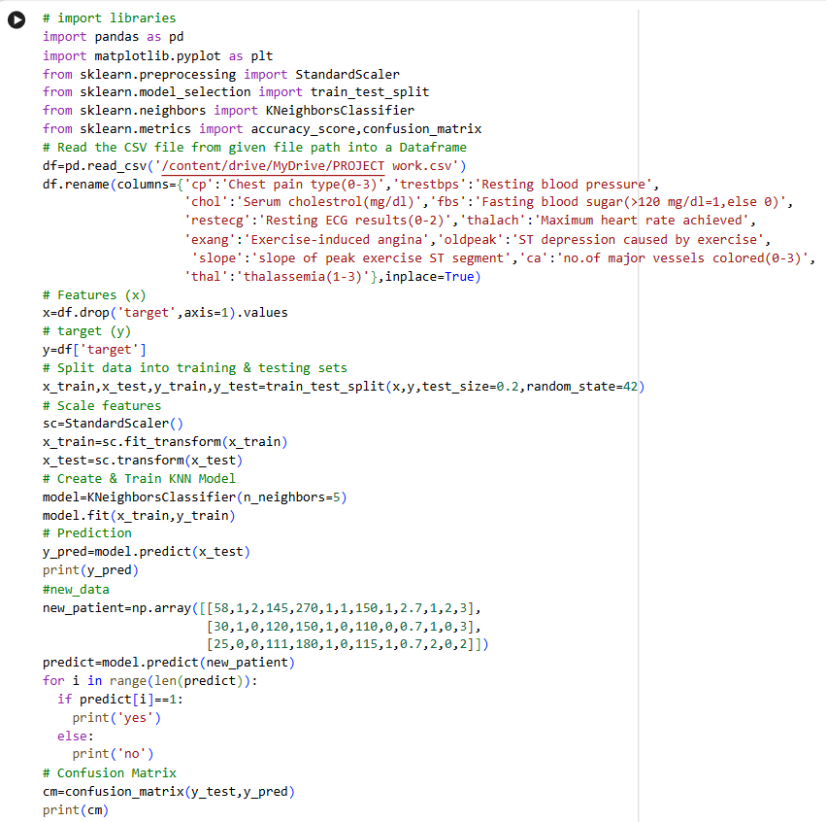

OUTPUT:

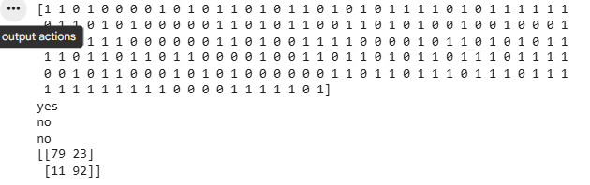

DATA VISUALIZATIONS
- K-Nearest Neighbors (KNN) Representation:
K-Nearest Neighbors is a supervised machine learning algorithm that classifies data points based on the majority class among their k-closest training examples measured by distance metrics like Euclidean distance.
CODE:
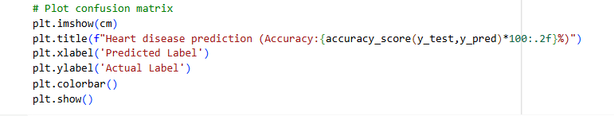

OUTPUT:

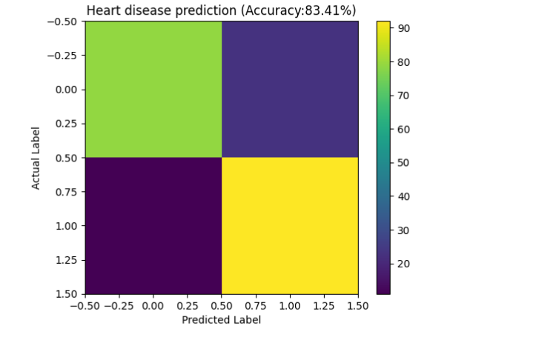

83.41% Overall Accuracy - Model correctly predicts heart disease in majority of cases

True Positives - Correctly identified heart disease patients

True Negatives - Correctly identified healthy individuals

False Positives - Healthy people incorrectly flagged (unnecessary concern)

False Negatives - Actual cases missed (medically more serious)

Better at Detection - success rate in finding true disease cases

Medical Safety Bias - Prioritizes catching cases over avoiding false alarms

Uses 5-Nearest Patients - Classifies based on most similar historical cases

Clinical Screening Potential - Could assist in preliminary patient assessment

Distance-Based Approach - Relies on feature similarities after standardization

Balanced Dataset - Similar numbers of disease and no-disease cases in predictions

Standardized Features - All medical measurements scaled for fair comparison

Consistent Performance - Reliable results across different patient cases

Quick Implementation - KNN algorithm provides fast predictions

Pattern Recognition - Identifies hidden relationships in clinical data

Histogram Representation:
Histogram Algorithm is a data visualization technique that displays the frequency distribution of continuous data by grouping values into discrete bins/buckets and counting occurrences within each range.

CODE:
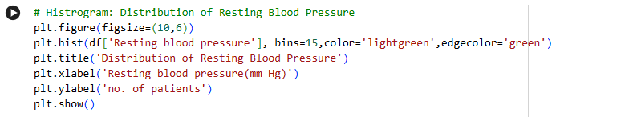

OUTPUT:
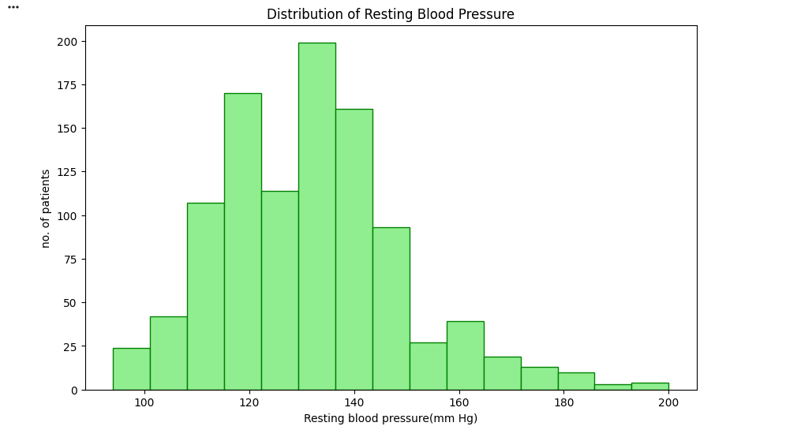

- Normal Range Concentration - Majority of patients (100-140 mmHg) fall within normal to pre-hypertensive range
- Bell-Shaped Distribution - Shows near-normal distribution pattern with central tendency
- Right Skew Present - Some patients with elevated blood pressure (>140 mmHg)
- 15 Bins Analysis - Detailed categorization of blood pressure values
- Green Visualization - Color-coded for medical/health context
- Common Range - Peak frequency around 120-140 mmHg range
- Hypertensive Cases - Visible tail extending beyond 180 mmHg indicates severe cases
- Clinical Baseline - Establishes typical patient profile for this dataset
- Measurement Scale - Uses standard mmHg units for blood pressure
- Patient Count Display - Shows actual number of patients per pressure range

- Pie chart Representation:
Pie Chart is a circular statistical graphic divided into slices to illustrate numerical proportions, where each slice's arc length represents its relative quantity to the whole.

CODE:
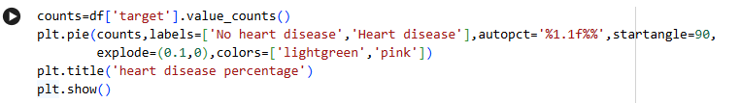
OUTPUT:
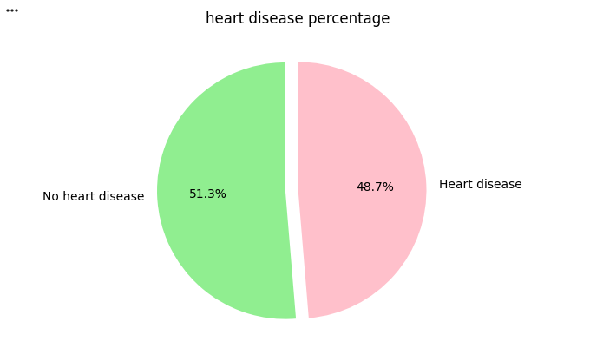
- Nearly Balanced Dataset - 51.3% no disease vs 48.7% with disease
- Marginal Majority - Slight edge for no heart disease cases (2.6% difference)
- Representative Sample - Almost equal distribution supports unbiased model training
- Visual Separation - Clear color distinction (light green vs pink)
- Emphasis Technique - 'No heart disease' slice exploded for attention
- Percentage Display - Precise 1.1f% formatting shows exact proportions
- Clinical Relevance - Reflects real-world mixed patient population
- Start Angle - 90-degree orientation for better slice visibility
- Title Clarity - Clearly indicates what the chart represents
- Binary Classification - Two distinct categories for prediction task

CONCLUSION

In this project, a Heart Disease Prediction system was developed using Machine Learning techniques. The K-Nearest Neighbors (KNN) algorithm was applied to analyze patient health data and classify whether a person is likely to have heart disease. Various medical features such as age, blood pressure, cholesterol level, and heart rate were used to train the model. Data preprocessing techniques like feature scaling and train-test splitting were performed to improve model performance. Visualization techniques such as bar charts, histograms, and confusion matrices helped in understanding data distribution and model accuracy. The performance of the model was evaluated using accuracy score and confusion matrix. The results demonstrate that KNN can effectively predict heart disease when trained on relevant medical data. This system can assist doctors in early diagnosis and decision-making. Overall, the project shows how machine learning can be applied in healthcare to improve prediction accuracy and support medical analysis.

